## Basics

REPL

Read Eval Print Loop

### IDEs

IDLE

PyCharm

VsCode

Visual Studio

Jupyter

Spyder

sorting

ASCII

## Naming Rules

Data & functions:

can have :

alphabets, numbers, underscore

starts with

alphabets, underscore

_hi =

ia =

room1 =

room_1 =

temp_to_increase_room_1

~~1room~~

~~room-1~~

## Key Words

True False

del

if elif else

## Data Types

int integer

whole numbers

float floating point numerals

decimals

str string (text)

complex (7 + 6i)

## Comments

# single line comments

## Functions

### general

print

type

len

input

eval

### cast (convert)

int

float

str

list

set

tuple

### sequences

sorted

max

min

## Operators

### arithmetic operators

+ add

- subtracts

/ div

* mul

% modulo

(remainder)

// floor division

** power

= assignment

### logical operators

and

or

not

### comparison (relational) operators

can be chained in python

< less than

> greater than

<= less than equal to

>= greater than equal to

== equal to

!= not equal to

### membership operators

in

not in

### identity operators

data types

is

is not

## Strings

text

index

out of bound error

negative index

slice

no error

|  |  |  |  |  |
| --- | --- | --- | --- | --- |
| R | o | g | e | r |
| 0 | 1 | 2 | 3 | 4 |
| -5 | -4 | -3 | -2 | -1 |

immutable

functions:

upper() lower() capitalize() title()

count, index, rfind

replace

## Data Structures

### list

any kind of data

index

negative index

slice

step

mutable

functions:

count, index

reverse, sort

insert, append, extend

remove, pop, clear

nesting

references

### tuple

any kind of data

index

negative index

slice

step

immutable

functions:

count, index

nesting

### set

unique values

no duplicates

unordered

no index

no slice

mutable

functions:

add,

discard, remove

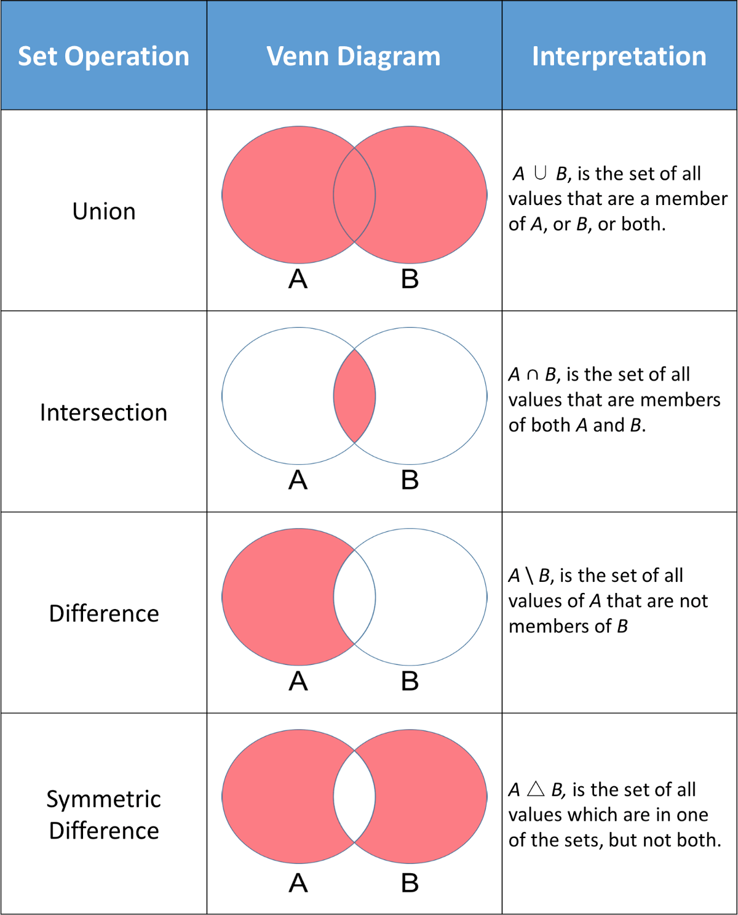

### dict

key:value

unordered (3.6)

ordered (3.7+)

mutable

values:

anything

keys:

immutable

unique

nesting

functions:

## bool

True

False

### False:

False (bool)

0

0.0

[ ]

{ }

''

None

## Flow Control

### if else

if

elif

else

nesting

### while

~~do-while~~

~~switch~~

extras:

exceptional handling